**P530/1**

**BIOLOGY**

**(Theory)**

**Paper 1**

**Jul/Aug 2016**

**2 ½ Hours**

**MUKONO EXAMINATIONS COUNCIL**

**Uganda Advanced Certificate of Education**

**BIOLOGY**

(Theory)

Paper 1

**2 Hours 30 Minutes**

**INSTRUCTIONS TO CANDIDATES**

* *Answer* ***all*** *questions in both sections* ***A*** *and* ***B***
* *Section* ***A:*** *Answers to this section* ***must*** *be written in the boxes provided.*
* *Section* ***B:*** *Answer to this section should be written in the spaces provided and not anywhere else.*
* *No additional sheet(s) of paper should be inserted in this booklet.*

|  |  |  |
| --- | --- | --- |
| ***For Examiner’s Use only*** | | |
| ***SECTION*** | ***MARKS*** | ***INITIALS*** |
| *Section A: 1-40* |  |  |
| *Section B: 41* |  |  |
| *42* |  |  |
| *43* |  |  |
| *44* |  |  |
| *45* |  |  |
| *46* |  |  |
| ***TOTAL*** |  |  |

**SECTION A (40 Marks)**

1. An organism has a genotype represented by GgTt. This organism can produce different types of gametes. The possible gametes would be represented by
2. G, g, T, t B. Gg, Gt, GT, gt

C. GG, gg, TT, tt D. GT, Gt, gT, gt

1. The leaves of some plants lose turgidity in hot dry weather. This happens because
2. The rate of respiration is greater than the rate of photosynthesis
3. The rate of photosynthesis is greater than the rate of respiration.
4. Water is lost through stomata faster than it is absorbed by the roots.
5. This response is a behavioural adaptation to ambient temperature variations.
6. The biochemical structure of cytochrome C in humans and chimpanzees is very similar. This suggests that
7. Humans and chimpanzees belong to the same species
8. Humans and chimpanzees had a common ancestor
9. Humans evolved from chimpanzees
10. Humans and chimpanzees evolved at the same time
11. Which one of the following is the importance of random segregation in meiosis?
12. It produces new combinations of the genetic information in gametes
13. It limits variation in genetic information
14. It halves the number of chromosomes in each cell
15. It produces new combinations of genes on chromosomes
16. Twenty percent (20%) of the nucleotide bases in human DNA are guanine (G). What is the percentage of adenine (A) bases in human DNA?
17. 20 B. 30 C. 40 D. 80
18. Which one of the following explains why phytoplanktons are usually found in the top few metres of water?
19. They have no swimming organs
20. Water is warmest in the top layers
21. Light does not penetrate far into water
22. The viscosity of water prevents them from sinking to the bottom.
23. The salt content of sea water is 3.5%, while the body of fish contain about 1.1% salt. This means that the tissues of fish living in seas water tend to
24. Lose water and gain salts. B. lose both water and salts

C. gain water and lose salts D. gain both water and salts.

1. When a bacterium enters the bloodstream of a mammal it acts as
2. a B- cell B. a T-cell

C. an antigen D. an antibody

1. The graph below shows the pattern traced by placing electrodes at a point on the axon of a nerve cell as it is stimulated.

G

E

F

H

+30

0

-30

K

-70

J

From the graph, it can be concluded that

1. The lowest potential, J, represents the resting potential of the nerve.
2. During phase F, fewer sodium ions are leaving the cell than entering it.
3. During phase K, the membrane will fail to respond to further stimulation
4. The stimulus applied only has an effect when the membrane potential is positive.
5. By what means do halophytes overcome the problem of physiological drought?
6. Developing aerial roots B. formation of casparian strips

C. storing water in their tissues D. Active secretion of salts.

1. Which one of the following is true of gluconeogenesis? It is
2. Step by step breakdown of glucose to pyruvate
3. Conversion of glucose to glycogen
4. Formation of glycogen from non-carbohydrate sources
5. Conversion of glycogen to glucose.
6. In a plant stem, the parenchyma of the secondary cortex is also called
7. Phelloderm B. Phellem

C. Periderm D. Phellogen

1. The learning which involves immediate understanding and correct response is
2. insight B. imprint

C. associate D. exploratory

1. which one of the following enzymes catalyses the addition or removal of a chemical group from substances other than by hydrolysis?
2. Peptides B. lyases

C. lipases D. phosphates

1. Which one of the following statements is NOT true of the insect’s skeleton?
2. Chitin is the main skeletal element
3. It is jointed and hence movable
4. It grows with the organism
5. It has muscles attached to it from the inside.
6. In an endotherm, which one of the following homeostatic responses would be produced by a sudden and prolonged decrease in ambient temperature?
7. Decreased uptake of oxygen
8. Decreased muscular activity
9. Decreased blood flow to the skin surface
10. Decreased rate of internal metabolic processes.
11. The graph shows information about four species of bacteria and their reproductive rates at different temperatures.

Generations per hour

Species Z

Species Y

Species X

3.0

Species W

1.0

0.3

0 10 20 30 40 50 60 70 80 90 100

Temperature /°C

What conclusion can be drawn from this graph?

1. All bacterial species can adapt to abroad range of temperatures
2. Individual species can reproduce in a broad range of temperatures
3. All bacterial species are limited to a range between O°C and 100°C
4. Individual species reproduce in relatively narrow range of temperatures.
5. Which one of the following animals does not belong to the taxonomic family canidae?
6. Jackal B. Wolf

C. Hunting dog D. Cheetah

1. The cofactor which is a small organic molecule that acts as a carrier molecule is called
2. Posthetic group B. co-enzyme

C. metal activator D. apoenzyme

1. A person’s diet consists of more protein than is needed for growth and reproduction. This causes increase in production of
2. Urine B. tactic acid

C. carbon dioxide D. urea

1. Protons accumulate in the thylakoid space during electron transport between photosystem I and II. The excess protons in the thylakoid space
2. enter the respiratory pathway
3. convert NADP to NADPH and generate ATP
4. raise the pH of the space until the process stops.
5. are small enough to diffuse back into the stroma.
6. Which one of the following photoreceptors occur in the fovea?
7. rods only B. cones only

C. rods and cones D. Rhodopsin

1. Which one of the following environmental factors affects transpiration but not evaporation?
2. Humidity B. wind speed

C. Temperature D. Light – intensity

1. Which property of water makes it suitable for use as a hydrostatic skeleton?
2. Water being denser than air
3. Water having a high tensile strength
4. Water being difficult to compress
5. Water having a high latent heat of vaporization
6. An absolute limit imposed by the environment on population increase is called
7. Biotic potential B. mortality

C. Carrying capacity D. environmental resistance

1. The lymph is slightly different from blood plasma in that it contains
2. Less proteins, more of other food materials and more waste products
3. Less proteins, less of other food materials and more waste products
4. Less proteins, less other food materials and less waste products.
5. More proteins, less of other food materials and less waste products.
6. The rapture of lysosomes in a cell would result into
7. Prolific lysis of cells and tissues
8. Prolific replication of cells and tissues
9. Reduced lysis of cells
10. Reduced growth of organs
11. Which one of these functions if performed by vasopressin?
12. It increases the amount of water reabsorbed by the nephron
13. It decreases the amount of water reabsorbed by the nephron
14. It promotes ultrafiltration
15. It increases sodium filtration
16. Stability in a fish during locomotion is provided by the following fins except?
17. Median B. ventral

C. pectoral D. Dorsal

1. The hormone which stimulates the secretion of pancreatic juices and inhibits gastric secretion is
2. Cholecystokisnin B. enterogastrone

C. gastrin D. cortisol

1. The hardy-weinberg principle can be applicable in the following instances except when
2. population is small
3. migration occurs only at the beginning of breeding season.
4. Mutations occur at a constant rate
5. Natural selection does not occur.
6. The significance of etiolation to a germinating seed in the soil is that it
7. Leads to rapid elongation of the hypocotyls in monocotyledonous plants
8. Allows maximum growth in length with minimum use of food reserves.
9. Allows the seedling to grow in the dark
10. Ensures that leaves remain small to break through the soil.
11. Which one of the following classes of organisms retains its embryological mytomes even at an adult stage?
12. Aves B. Pisces

C. Mammalia D. Reptilia

1. The low RQ values after some days of germination may be attributed to
2. High reserve food content
3. Great need for energy production of seed germination
4. Inability of oxygen to diffuse to embryo
5. Utilization of food reserves other than sugars.
6. Prolonged menstrual periods may be caused by
7. High levels of luteinizing hormone
8. A decrease in production of follicle stimulating hormone
9. High levels of luteinizing hormone
10. A deficiency of oestrogen
11. Which one of the following factors is least likely to contribute to the development of new species?
12. Chromosomal changes B. Gene mutations

C. Environmental stability D. geographical isolation

1. Excessive use of pesticides is dangerous because
2. they cause eutrophication B. they cause pest resistance

C. they cause bioaccumulation D. they cause biomagnifications

1. A feeding relationship that proceeds from grass to rabbits, fox and lion is best described as
2. food web B. structural feed relation

C. food chain D. continuous eating.

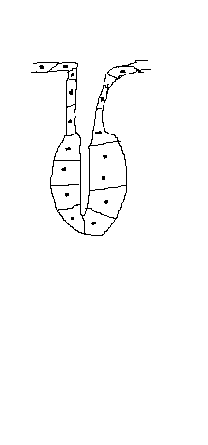

1. Which type of gland shown in the figure

above is

1. Exocrine

Duct

1. Endocrine
2. Apocrine
3. Eccrine
4. Which one of the following is NOT an intermediate compound in the ornithine cycle?
5. Ornithine B. Citrulline

C. Arginine D. Ammonia

**SECTION B**

*All answer must be written in space provided*

1. a) Some people cannot digest lactose in adulthood like in their childhood. Explain why these adults get diarrhoea when they drink milk? ***(03marks)***

.............................................................................................................................................................................................................................................................................................................................................................................................................................................................................................................................................................................................................................................................................................................................................................................................................................................................................................................................................

b) Scientists investigated how effective two oral rehydration solutions, A and B, were in treating patients with diarrhea.

* Solution A contained glucose
* Solution B was identical to A, except that glucose was replaced with starch.

The graph shows their results.

Solution B with Starch

100

Percentage of patients without diarrhea

75

Solution A with glucose

50

25

0 1 2 3

Time / days

1. Explain the difference in the percentage of patients without diarrhea between solution B and solution A for the first day. ***(04marks)***

.............................................................................................................................................................................................................................................................................................................................................................................................................................................................................................................................................................................................................................................................................................................................................................................................................................................................................................................................................

……………………………………………………………………………………………………………………………………………………………………………………………………………………………………………………………………

1. Calculate the difference in the number of patients without diarrhea after I day’s treatment with solution A and those without diarrhea after 1 day’s treatment with solution B. ***(02marks)***

.............................................................................................................................................................................................................................................................................................................................................................................................................................................................................................................................................................................................................................................................................................................................................................................................................................................................................................................................................

............................................................................................................................................................................................................................................................................................................................................................................

1. Explain the effect of oral rehydration salts on treatment of diarrhea in children. ***(01mark)***

.............................................................................................................................................................................................................................................................................................................................................................................................................................................................................................................................................................................................................................................................................................................................................................................................................................................................................................................................................

1. The diagram shows a cholera bacterium. It has been magnified 50,000 times.

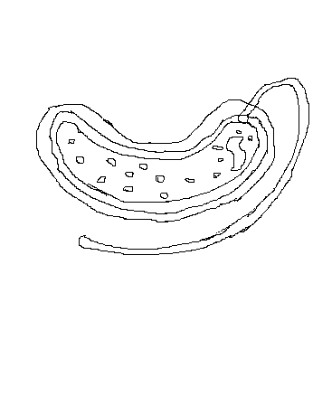

A

B

C

1. Name A

............................................................................................................................................................................

1. Give two structures presents in an epithelial cell from the ileum that are not present in the figure above. ***(02marks)***

.............................................................................................................................................................................................................................................................................................................................................................................................................................................................................................................................................................................................................................................................................................................................................................................................................................................................................................................................................

1. The bacteria can be viewed using a transmission electron microscope (TEM) or scanning electron microscope. (SEM).
2. Give one advantage of using TEM rather than SEM. ***(01mark)***

..............................................................................................................................................................................................................................................................................................................................................................

1. Give one advantage of using SEM rather than TEM. ***(01mark)***

..............................................................................................................................................................................................................................................................................................................................................................

1. Calculate the actual width of the cholera bacterium between points B and C giving your answer in micrometers. ***(02marks)***

.............................................................................................................................................................................................................................................................................................................................................................................................................................................................................................................................................

1. The graph below shows the relationship between the number of deaths from cholera and the height at which people live above sea level.

Number of deaths per 10,000 from cholera

100

80

60

40

20

0 20 40 60 80 100 120

Height above sea level /M

1. Explain the relationship between the number of deaths from cholera and the height at which people live above sea level. ***(03marks)***

.............................................................................................................................................................................................................................................................................................................................................................................................................................................................................................................................................

1. The graph below shows the volume of air an asthma individual breathed out in the first 6 seconds of a breath. Curve A shows volume before he used an inhaler.

Total volume of air breathed out /dm3

5

Curve B

4

3

Curve A

2

1

0 1 2 3 4 5 6

Time / s

1. Explain how the diaphragm brings about the changes in curve A. ***(03marks)***

.............................................................................................................................................................................................................................................................................................................................................................................................................................................................................................................................................

1. Describe how you would use curve A to find the total volume of air that this person could breathe out in one complete breath. ***(03marks)***

.............................................................................................................................................................................................................................................................................................................................................................................................................................................................................................................................................

1. Explain the difference in the volume of air breathed out between curve A and B. ***(04marks)***

............................................................................................................................................................................................................................................................................................................................................................................................................................................................................................................................................

…………………………………………………………………………………………………………………………...

1. a) Explain the myogenic nature of a cardiac muscles. ***(03marks)***

................................................................................................................................................................................................................................................................................................................................................................................................................................................................................................................................................................

b) (i) In which chamber of the heart does pressure reach the highest value? ***(01mark)***

.............................................................................................................................................................................................................................................................................................................................................................................................................................................................................................................................................

1. Explain how the structure of this chamber causes this high pressure. ***(01mark)***

.............................................................................................................................................................................................................................................................................................................................................................................................................................................................................................................................................

c) Figure below shows the volume of blood in a man’s right ventricle at different times

during one cardiac cycle.

|  |  |
| --- | --- |
| Time / s | Volume of blood /cm3 |
| 0.0 | 125 |
| 0.1 | 148 |
| 0.2 | 103 |
| 0.3 | 70 |
| 0.4 | 56 |
| 0.5 | 55 |
| 0.6 | 98 |
| 0.7 | 125 |

1. (i) Using the data above;

Calculate the man’s heart rate in beats per minutes.

.............................................................................................................................................................................................................................................................................................................................................................................................................................................................................................................................................

(ii) Calculate the man’s cardiac output in cm3 per minute. ***(03marks)***

.............................................................................................................................................................................................................................................................................................................................................................................................................................................................................................................................................

1. Show whether the valves are open or closed at each of the times shown in table below; ***(02marks)***

|  |  |  |
| --- | --- | --- |
| Time /s | Valves between right atrium and right ventricle | Valves between right ventricle and pulmonary artery |
| 0.2 | …………………………. | ……………………………… |
| 0.6 | ………………………….. | ……………………………… |

1. The diagram shows the structure of the cell-surface membrane of a cell.

B

C

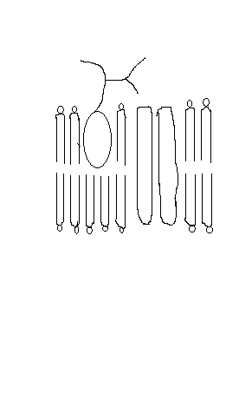

1. Name A and B ***(02marks)***

A: ……………………………………………………………………………………………………………………

B: ……………………………………………………………………………………………………………………

A

b) (i) C is a protein with a carbohydrate attached to it. This carbohydrate is formed by

joining monossacharides together.

Name the type of reaction that joins monossacharides together. ***(01mark)***

...............................................................................................................................................................................

ii) Name the organelle that is found in mucus secreting cells and its role;

Organelle:……………………………………………………………………………………………………………

Role: ………………………………………………………………………………………………….***(02marks)***

c) The diagram shows part of an epithelial cell from an insect’s gut.

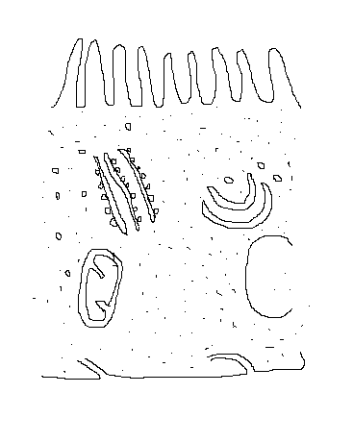

Ribosomes on endoplasmic reticulum

Blood

Mitochondrion

Golgi apparatus

Microvillus

Lumen of gut

Explain how cell above is adapted for each of the following functions.

1. Active transport of substances. ***(02marks)***

................................................................................................................................................................................................................................................................................................................................................................................................................................................................................................................................................................

1. The synthesis of enzymes. ***(02marks)***

...............................................................................................................................................................................................................................................................................................................................................................................................................................................................................................................................................................

1. Rapid diffusion of substances from lumen into cytoplasm. ***(01mark)***

................................................................................................................................................................................................................................................................................................................................................................................................................................................................................................................................................................

1. The graph shows the effect of substrate concentration on the rate of an enzyme controlled reaction.

D

C

B

Rate of reaction

A

0 10 20 30 40 50 60

Substrate concentration

(Arbitrary units)

1. (i) Describe what the graph shows about the effect of substrate concentration on the rate of this enzyme controlled reactions. ***(03marks)***

.............................................................................................................................................................................................................................................................................................................................................................................................................................................................................................................................................

(ii) What limits the rate of reaction between points A and B? Give the evidence from

the graph for this. ***(02marks)***

.............................................................................................................................................................................................................................................................................................................................................................................................................................................................................................................................................

(iii) Suggest a reason for the graph shape between points C and D. ***(01mark)***

.............................................................................................................................................................................................................................................................................................................................................................................................................................................................................................................................................

1. Sketch a curve on the graph to show the rate of this reaction in the presence of a competitive inhibitor. ***(02marks)***
2. Explain how drugs lower the rate of reaction. ***(02marks)***

.............................................................................................................................................................................................................................................................................................................................................................................................................................................................................................................................................

***End -***